### **Halloween Haunted House Cascade Card**

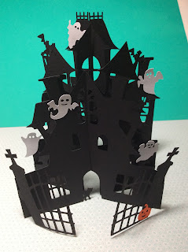

This haunted house is very cute as a cascade card. This card folds flat for mailing. It is 4 1/2 inches wide and 5 inches tall. I used black card stock to make this card.

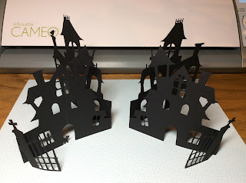

The two shapes are folded as shown above.

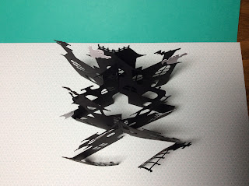

The two pieces slide together to form two X's.

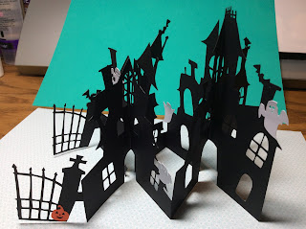

Side View